Interior Region in Solid Geometry

Definition
# Source: AI Source: Provided by: [Data Path: Persons Table -> ID Column: 1, Name_En Column: Motasem Essam] -> From: [ChatGPT] on [7/25/2026]
An interior region in solid geometry is the collection of points that lie strictly inside a three-dimensional region, excluding its boundary. These points are surrounded by the region and are not located on its outer surface, edges, or vertices.
The interior of a solid may be enclosed by flat surfaces, curved surfaces, or a combination of both. Examples include points inside a cube, points inside a sphere, and points inside a pyramid.
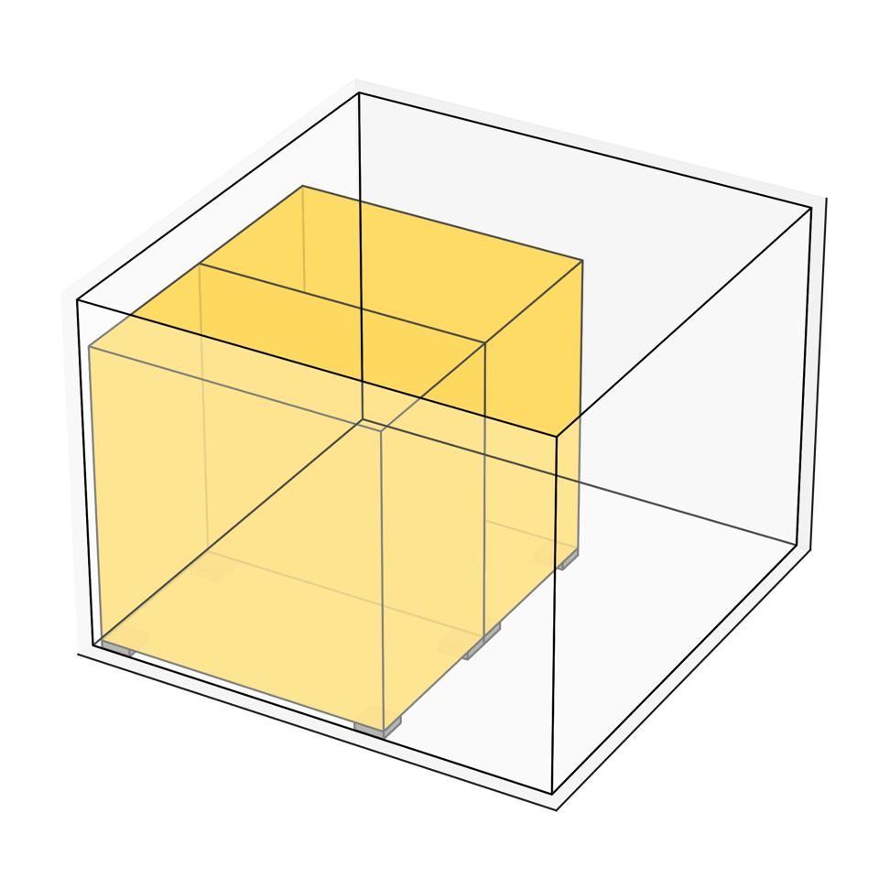
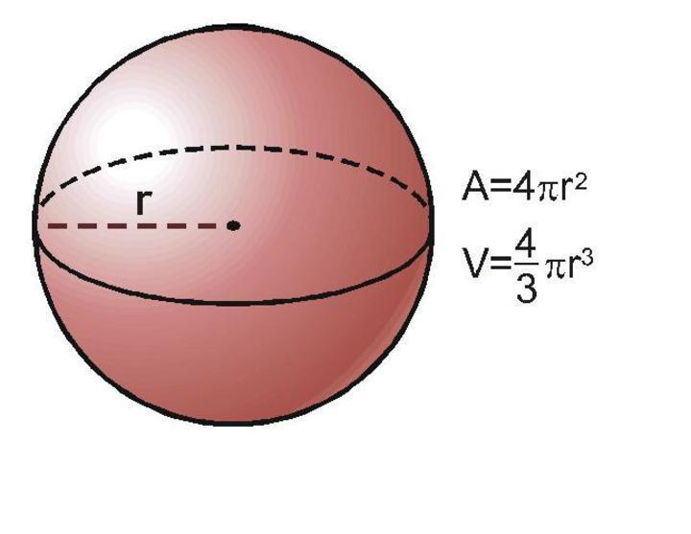
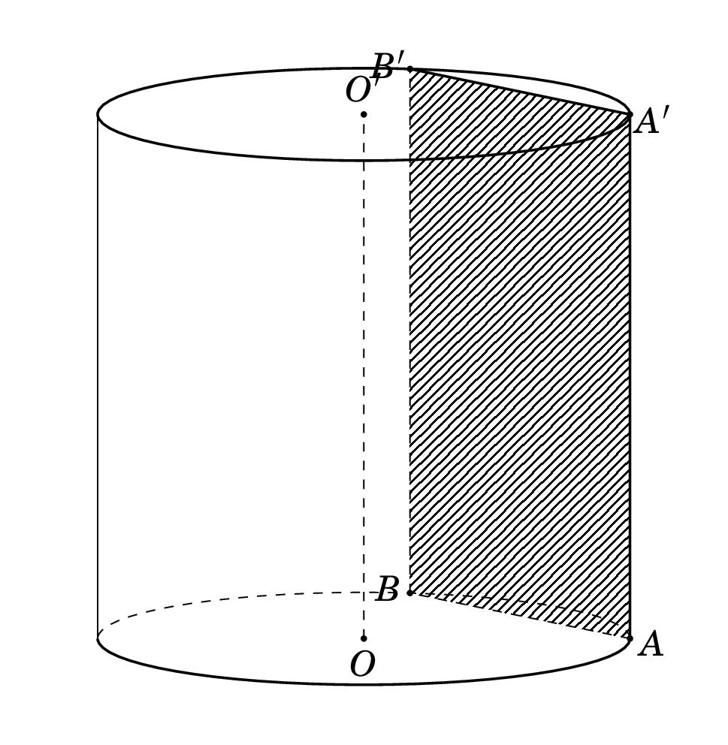

Simple Definition
# Source: AI Source: Provided by: [Data Path: Persons Table -> ID Column: 1, Name_En Column: Motasem Essam] -> From: [ChatGPT] on [7/25/2026]
An interior region is the space inside a solid, excluding its boundary.
For example:
- A point in the middle of a cube is an interior point.
- A point inside a ball, but not on its spherical surface, is an interior point.
- A point inside a pyramid, away from its faces, edges, and vertices, is an interior point.
A point on the surface is a boundary point, not an interior point.

Key Characteristics
# Source: AI Source: Provided by: [Data Path: Persons Table -> ID Column: 1, Name_En Column: Motasem Essam] -> From: [ChatGPT] on [7/25/2026]
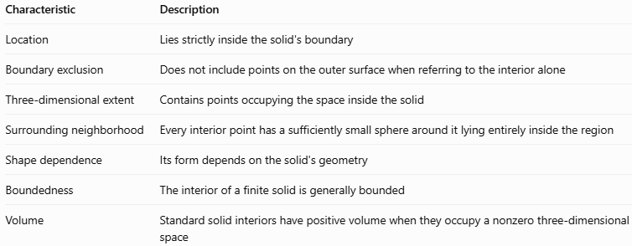
Characteristic | Description
Location | Lies strictly inside the solid's boundary
Boundary exclusion | Does not include points on the outer surface when referring to the interior alone
Three-dimensional extent | Contains points occupying the space inside the solid
Surrounding neighborhood | Every interior point has a sufficiently small sphere around it lying entirely inside the region
Shape dependence | Its form depends on the solid's geometry
Boundedness | The interior of a finite solid is generally bounded
Volume | Standard solid interiors have positive volume when they occupy a nonzero three-dimensional space
Important distinction: The interior region is not the same as the entire solid when the solid includes its boundary. For example, a closed ball includes both its interior and its spherical surface, while its interior excludes the surface.

Geometric Representation
# Source: AI Source: Provided by: [Data Path: Persons Table -> ID Column: 1, Name_En Column: Motasem Essam] -> From: [ChatGPT] on [7/25/2026]
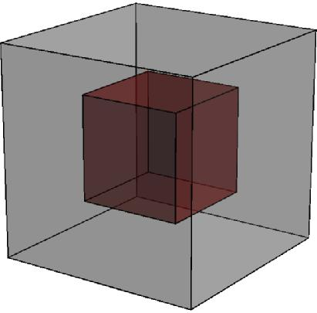
An interior point lies inside the solid and away from its boundary. The surface encloses the interior but is not part of the interior itself.
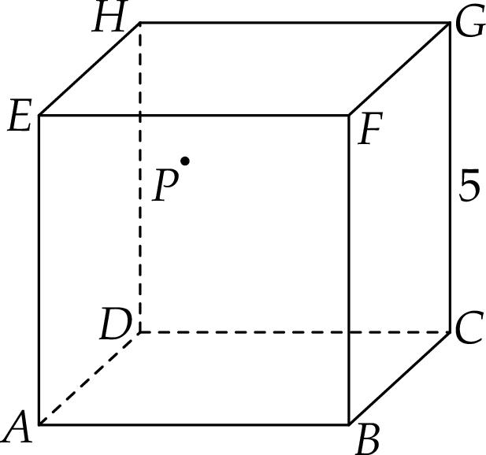
Interior of a cube
A point strictly between all six faces is an interior point. It does not lie on a face, edge, or vertex.
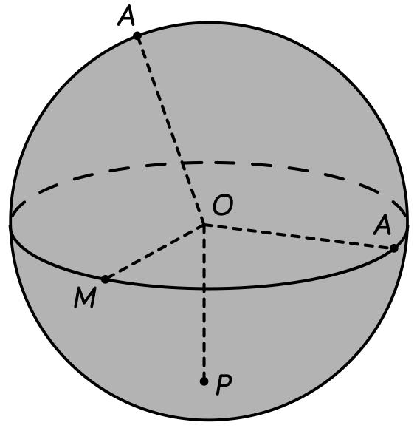
Interior of a sphere
Points whose distance from the center is less than the radius belong to the interior. Points at exactly the radius lie on the surface.
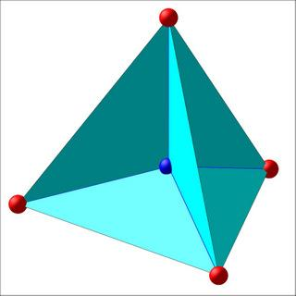
Interior of a pyramid
Points inside all the faces of the pyramid belong to its interior, provided they do not lie on the boundary.

Mathematical Representation

Interior of a sphere
# Source: AI Source: Provided by: [Data Path: Persons Table -> ID Column: 1, Name_En Column: Motasem Essam] -> From: [ChatGPT] on [7/25/2026]
A sphere of radius $r$ centered at the origin has the surface equation
$$x^{2}+y^{2}+z^{2}=r^{2}$$
Its interior region is described by
$$x^{2}+y^{2}+z^{2}<r^{2}$$
The strict inequality means that the distance from the origin is less than the radius.
For a sphere centered at $\left(a,b,c\right)$, the interior is
$${\left(x-a\right)}^{2}+{\left(y-b\right)}^{2}+{\left(z-c\right)}^{2}<r^{2}$$

Interior of a cube
# Source: AI Source: Provided by: [Data Path: Persons Table -> ID Column: 1, Name_En Column: Motasem Essam] -> From: [ChatGPT] on [7/25/2026]
Suppose a cube occupies the region from $0$ to $s$ along each coordinate axis.
Its interior is
$$0<x<s, 0<y<s, 0<z<s$$
The strict inequalities exclude all six faces, including their edges and vertices.
For a cube with side length $4$, the point $\left(2,2,2\right)$ is an interior point, while $\left(0,2,2\right)$ lies on a face.

General mathematical definition
# Source: AI Source: Provided by: [Data Path: Persons Table -> ID Column: 1, Name_En Column: Motasem Essam] -> From: [ChatGPT] on [7/25/2026]
A point $P$ is an interior point of a region $R$ if there exists a sufficiently small positive radius $ε$ such that every point within distance $ε$ of $P$ belongs to $R$.
$$B\left(P,ε\right)⊆R$$
Here, $B\left(P,ε\right)$ denotes an open ball centered at $P$ with radius $ε$.
This definition captures the idea that an interior point has some space around it without crossing the region's boundary.

Worked Examples
# Source: AI Source: Provided by: [Data Path: Persons Table -> ID Column: 1, Name_En Column: Motasem Essam] -> From: [ChatGPT] on [7/25/2026]
Example 1: Determine whether a point lies inside a sphere
A sphere has center $\left(0,0,0\right)$ and radius $5$. Determine whether $P=\left(2,1,2\right)$ lies in its interior.
Solution:
Calculate the distance from the center:
$$d=\sqrt{2^{2}+1^{2}+2^{2}}=\sqrt{9}=3$$
Since $3<5$, the point lies strictly inside the sphere.
Answer: $P$ is an interior point.
Example 2: Determine whether a point lies inside a cube
A cube is defined by
$$0≤x,y,z≤6$$
Consider $P=\left(3,2,4\right)$.
Solution:
All three coordinates are strictly between $0$ and $6$:
$$0<3<6, 0<2<6, 0<4<6$$
Therefore, the point lies inside the cube, away from all its faces.
Answer: $P$ belongs to the interior region.
Example 3: Distinguish an interior point from a boundary point
Consider a sphere of radius $4$ centered at the origin. Classify these points:
- $A=\left(1,1,1\right)$
- $B=\left(4,0,0\right)$
- $C=\left(5,0,0\right)$
Solution:
For $A$,
$$\sqrt{1^{2}+1^{2}+1^{2}}=\sqrt{3}<4$$
So $A$ is an interior point.
For $B$,
$$\sqrt{4^{2}+0^{2}+0^{2}}=4$$
So $B$ lies on the boundary.
For $C$,
$$\sqrt{5^{2}+0^{2}+0^{2}}=5>4$$
So $C$ lies outside the sphere.
Answer: $A$ is interior, $B$ is on the boundary, and $C$ is exterior.
Example 4: Calculate the volume of a spherical interior
A sphere has radius $3$ units. Find the volume of its interior.
Solution:
The volume is calculated using
$$V=\frac{4}{3}πr^{3}$$
Substituting $r=3$,
$$V=\frac{4}{3}π{\left(3\right)}^{3}=36π$$
Therefore, the interior occupies a volume of $36π$ cubic units, approximately $113.10$ cubic units.
Excluding the surface does not change this volume.

Comparison With Related Concepts
# Source: AI Source: Provided by: [Data Path: Persons Table -> ID Column: 1, Name_En Column: Motasem Essam] -> From: [ChatGPT] on [7/25/2026]
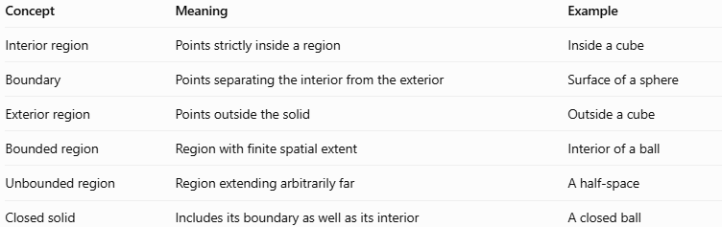
Concept | Meaning | Example
Interior region | Points strictly inside a region | Inside a cube
Boundary | Points separating the interior from the exterior | Surface of a sphere
Exterior region | Points outside the solid | Outside a cube
Bounded region | Region with finite spatial extent | Interior of a ball
Unbounded region | Region extending arbitrarily far | A half-space
Closed solid | Includes its boundary as well as its interior | A closed ball

Applications
# Source: AI Source: Provided by: [Data Path: Persons Table -> ID Column: 1, Name_En Column: Motasem Essam] -> From: [ChatGPT] on [7/25/2026]
- Three-dimensional modeling: Identifying which points belong inside a modeled object.
- Computer graphics: Determining whether a camera, light source, or object lies inside a solid.
- Engineering: Describing the internal space of mechanical components.
- Physics: Modeling the volume occupied by an object.
- Calculus: Defining regions for triple integration and volume calculations.
- Collision detection: Checking whether an object or point has entered a solid's interior.

Key Points
# Source: AI Source: Provided by: [Data Path: Persons Table -> ID Column: 1, Name_En Column: Motasem Essam] -> From: [ChatGPT] on [7/25/2026]
- An interior region consists of points strictly inside a three-dimensional region.
- Interior points do not lie on the boundary.
- A point inside a sphere has a distance from its center less than the radius.
- For a cube, an interior point must lie strictly between the coordinate limits defining its faces.
- The interior of a typical finite solid is bounded.
- The interior, boundary, and exterior are distinct concepts.
- Excluding the boundary does not change the volume of ordinary three-dimensional solids.

Conclusion
# Source: AI Source: Provided by: [Data Path: Persons Table -> ID Column: 1, Name_En Column: Motasem Essam] -> From: [ChatGPT] on [7/25/2026]
An interior region in solid geometry is the space contained strictly within a solid's boundary. It includes all points surrounded by the solid's surface while excluding the surface itself. Understanding interior regions is essential for classifying points in space, describing geometric solids, and performing volume calculations.

